NX Cam postprocessor for the PocketNC V1 and PocketNC V2-10

This post has a B Table Offset set to 0.841” for V1 and 0.8314” for V2-10 but can be easily changed to suit your machine kinematic dimensions.(see below) You must change this value in the post otherwise 5-axis operations will have positional errors. Every Machine is unique and modifying the postprocessor is part of the normal machine commissioning process. There is also an expression called baxis_offset you can edit to suit your particular PocketNC that will update the 3D model for accurate collision checking during simulation. Please move your fixtures and vises etc. to the correct locations. I have added the adapter and vise to the V2 machine.

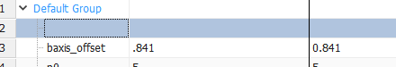

First of all you need to import the correct “.mtk for you machine via the machine tool builder application.

The next step is to edit the expression “B_Table_Offset” to match your machines B Table offset supplied from the Team at PocketNC when you purchased the machine.

This will update the graphics and position of the vice

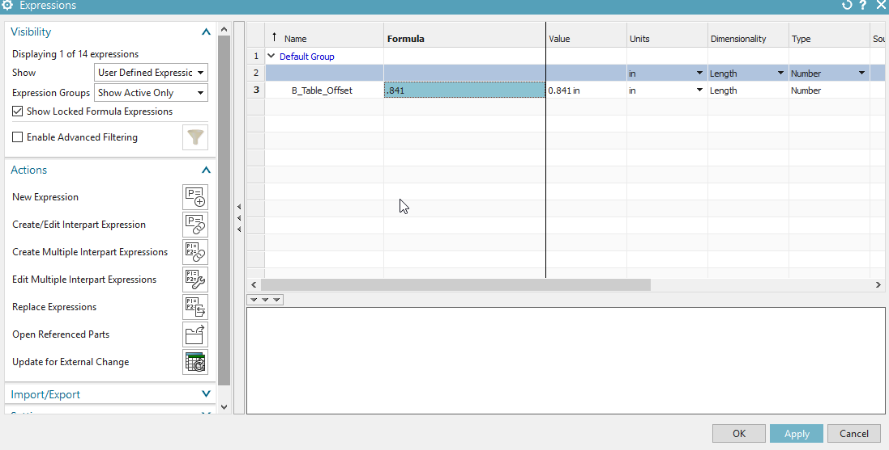

Next step is to open Post Configurator and modify the 5th Axis point in the Real Machine Kinematics tab to match your machines B Table Offset supplied by PocketNC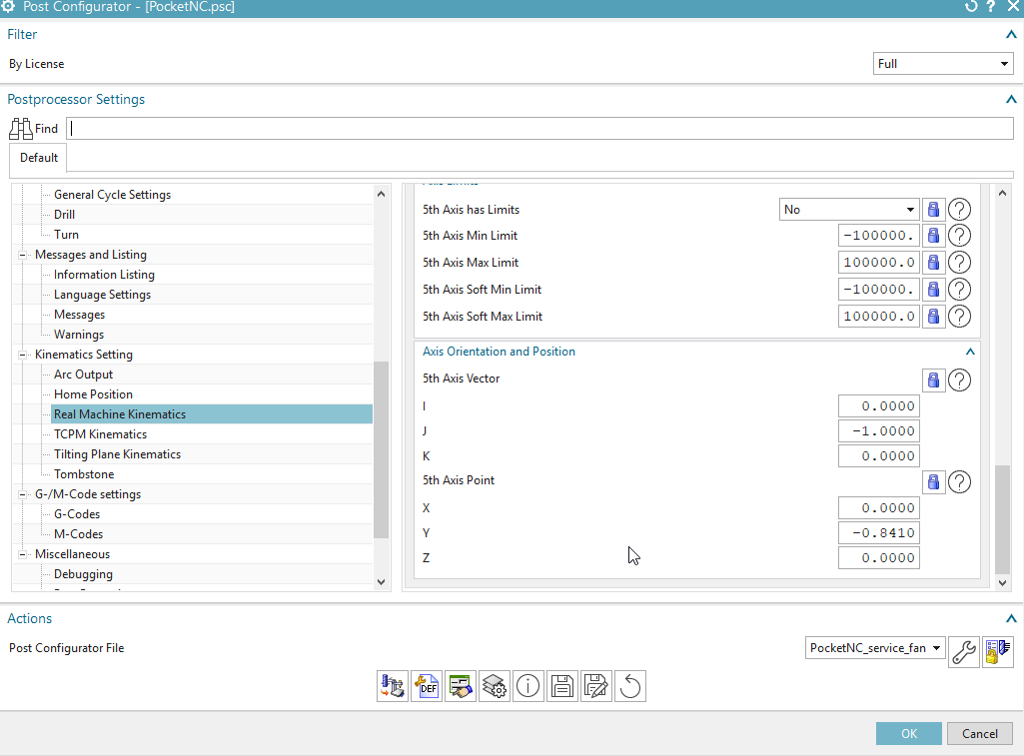

Next go to the Machine Tool Navigator and edit the B_Axis Machine Component.

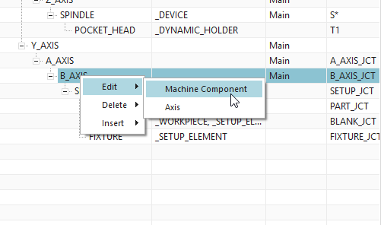

And move the CSYS to the arc center of the B-Axis table and save the pocketncam.prt file

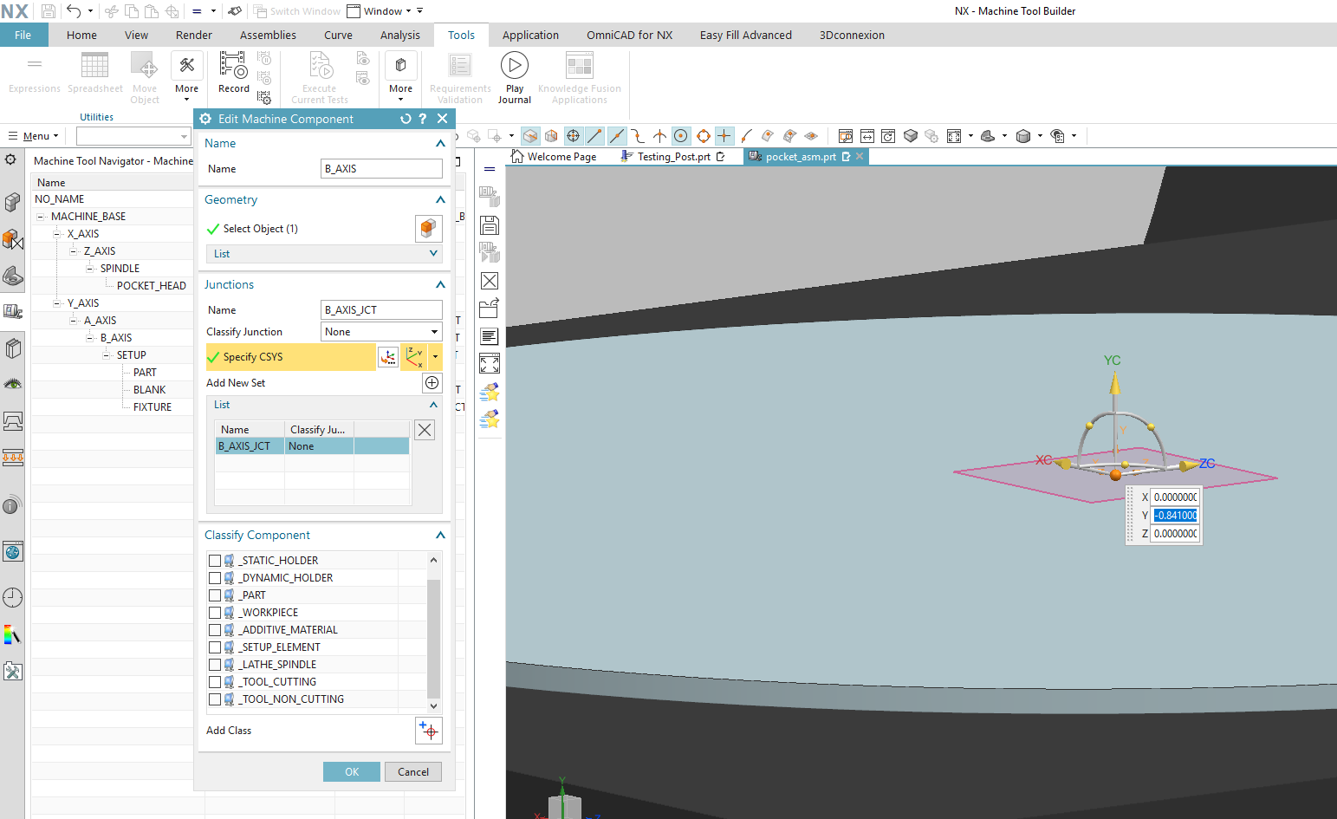

That’s the final step. You can now use the postprocessor and machine simulation using G-Code or TLDATA. I recommend Machine(G) Code for 100% accuracy of motion.

**Changes from V2_PocketNC_v1 to xxxx**

Initial release

All V1PocketNCv7 exists in V2_PocketNC_v1 with changes to allow for increased kinematic range and feedrates.

**Changes from V1_PocketNC_v7 to V1_PocketNC_v6**

Naming convention changed to suit both V1 and V2 machines now

Upgraded post libraries to V5.4.0

Increased number of allowable tools from 30 to 55 to match the PocketNC controller

**Changes from V4 to V6**

Fixed the dwell output to M4 Px . It was M4 Xx which caused an error

Removed the extra M6 that would cause an error on V2-10 and V2-50 machines

Added support for the Rotate UDE so now you can select which quadrant on the A or B table you would like to machine it. E.g. Setting a B quadrant that is close to the A rotation will help with rigidity. Image below is example of how to use.

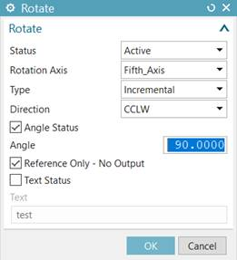

No longer resetting A and B axis to zero at tool change or end of operation. Only a G53 Z0 command then turn back on G54 for local coordinates. This is to overcome the fact Linuxcnc doesn’t support G28 Machine Positioning.

Any addition questions please feel free to message me on the [PocketNC forums](https://community.pocketnc.com/categories) or the [Facebook group](https://www.facebook.com/groups/182982852288164).

TokyoPav